Commuter Challenge Email Templates: Week 2 (May 13-19)
Missoula In Motion has prepared some sample email messages that we hope might be useful to you as you spread the word about the Commuter Challenge in your workplace. Feel free to use and/or edit the materials to suit your purposes, style, weather etc. (please note the red bolds and edit as appropriate):

Day 9 (Monday, 5/14)
We’ve all had the weekend off to recover, relax and reenergize. We should be in better condition to really step it up this week and leave the competition in the dust. If you have been unable to participate, that’s unfortunate, but remember you still have a chance to be entered into the raffle by logging just ONE sustainable trip, ONE time this week. If everyone does just that… we achieve All-Star Team Status! Good luck everyone!

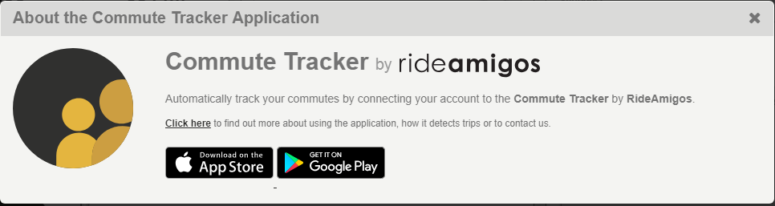
Download the App: By now, you have all discovered how easy it is to log trips. But did you know that it gets even easier?! Don’t believe me? – download the free “Commute Tracker” app and see for yourself. The app will track you as you travel between your home address and your workplace so that when you arrive, all you need to do is confirm your mode and the rest of the work is done for you. Your trips will automatically be logged to your account.
See how the competition is shaping up on the Challenge Leaderboards!

Micro-Sized Employers: https://waytogo.missoulainmotion.com/s/commuter-challenge-micri8
Small Employers: https://waytogo.missoulainmotion.com/s/commuter-challenge-smal1e
Medium Employers: https://waytogo.missoulainmotion.com/s/commuter-challenge-medik8
Large Employers: https://waytogo.missoulainmotion.com/s/commuter-challenge-largj8
Macro-Employers: https://waytogo.missoulainmotion.com/s/commuter-challenge-macrnh

Signed, XXXXXX
Your Commuter Challenge Captain

Day 10 (Tuesday, 5/15)

We are all experts at logging trips by now, but have you discovered the nifty “Favorite Trip” feature? It allows you to save your frequently traveled routes so that you don’t have to re-enter mileage or the start and end destinations when using the trip planning tool. Here’s a short video on how to save a Favorite Trip.
As our wise culture has taught us, doing something awesome in your life doesn’t actually count unless you take a photo of yourself doing the awesome thing, post the photo on social media and get an acceptable number of likes. I mean, how can I trust that you’ve really been carpooling to work every day without a seeing selfie to prove it?
It’s time to step up Team WORKPLACE’S social media game! Tag @missoulainmotion or use #missoulainmotion to be in the running for Best Social Media Presence, Best Carpool/Vanpool Selfie and Best Team Photo. Best Team Photo winners get a collection of office mugs customized with the winning photo - something to remind them of the glorious achievement for years to come!
Keep up the good work!
Signed, XXXXXX
Your Commuter Challenge Captain

Day 12 (Tuesday, 5/17)

Do you have any fun commute stories from the past week and a half? If so, you should share them with everyone. (Perhaps start by sharing one of your own stories).

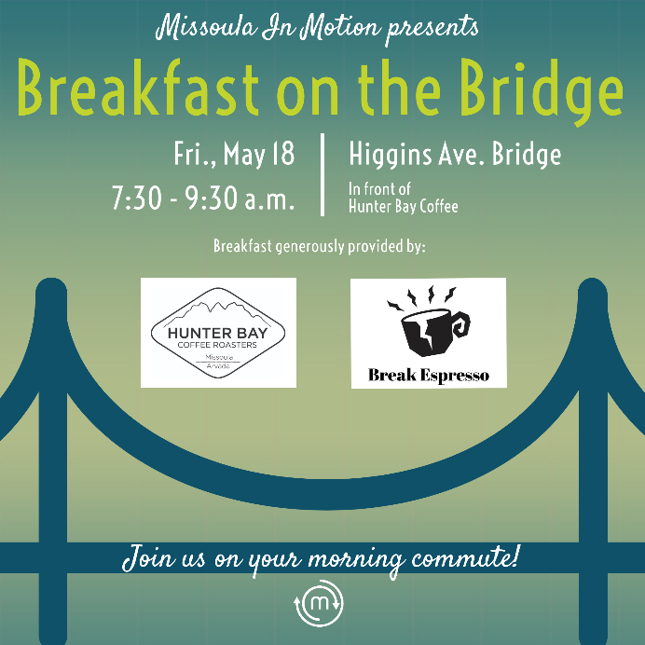
Guys. Real talk. Tomorrow is our last chance as a team to get everyone to make just ONE sustainable trip. Go team!
Oh, and to celebrate International Bike to Work Day tomorrow, Missoula In Motion’s free commuter breakfast will be at the Higgins St. Bridge (outside of Hunter Bay), 7:30 – 9:30AM. In addition to coffee and breakfast treats, there will be some additional raffle prizes for anyone who stops by on their sustainable commute (not limited to bikers!).

I also want to remind you to save the date for the Commuter Challenge Crowning Ceremony and Party on Wednesday, May 30th from 5-7pm at Burns St. Bistro. Let’s go represent WORKPLACE as a team! Who is with me?

Signed, XXXXXXX
Your Commuter Challenge Captain

Day 13 (Friday 5/18)

TGIF! TODAY/tomorrow/Sunday(depending on whether your team works weekends) is the last day!

Many of you are still dreaming of your free ice cream for achieving the 10-Day Medalist status this year - Congratulations! Others are showing off their completed Gold Medal Training Plans knowing that they’ve got a sweet prize coming their way.

Remember, ALL sustainable commutes must be logged at waytogo.missoulainmotion.com by Friday, May 25th at 5pm. But, you should go ahead and do it now!

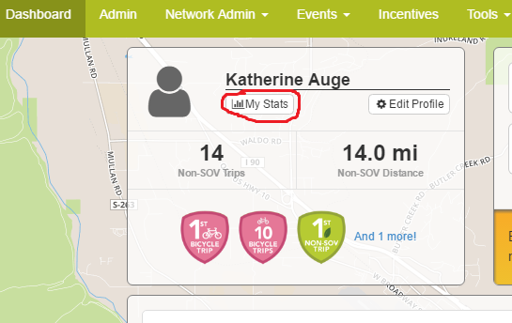
Now that the challenge is wrapping up, you can calculate the amount of CO2 your sustainable trips diverted as well as the cash-money you saved! To find these stats, simply login at waytogo.missoulainmotion.com and open your “Dashboard”. From there you can select the “My stats” button under your name in the upper left-hand corner (see below). If you logged trips back in April be sure to select that the display show stats for “this month” only.

Thanks to everyone for your efforts these past two weeks! I'll keep you posted on our participation total - cross your fingers!

Signed, XXXXXX
Your Commuter Challenge Captain

